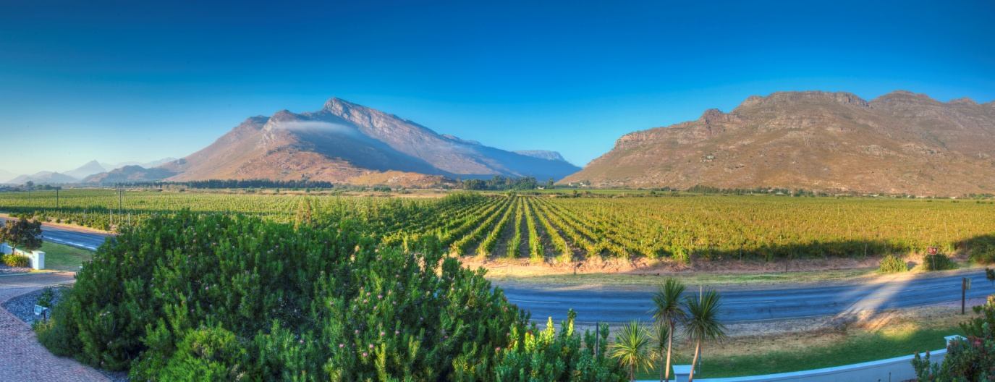

***BERGSIG ESTATE***

*Bergsig Estate – offers “A tradition of quality” in “the valley of the slow-ripening grape”*

*Bergsig Estate is one of the oldest family run estates in South Africa and a proud member of the Breedekloof wine route. Bergsig produces a wide range of highly awarded wines. Visit Bergsig Estate for a tasting at ProWein WOSA Pavillion, 9B28, Stand 3*