Cape Town, 03 June 2014
Release: Immediate

SOUTH AFRICA LEADS FAIRTRADE WINE PRODUCTION
AS GLOBAL SALES RISE BY 27%

Global sales of Fairtrade wine grew by 27% in 2013, with over 20,8 million litres of wine sold with the iconic Fairtrade label displayed on the bottles. As the biggest producing country of Fairtrade wine in the world, South Africa is the global leader in the promotion of ethical and sustainable wine grape production.

“Approximately two thirds of all Fairtrade wine sold globally comes from South Africa,” comments Ms Arianna Baldo, Executive Director of Fairtrade Label South Africa and Wine Product Coordinator for Fairtrade International. “The UK, Netherlands and Sweden remain leading markets, however we are seeing a rise in non traditional markets like Ireland, Japan, the USA and, last but not least, South Africa”.

The market for Fairtrade wine in South Africa grew by 12,5%, with over 460 thousand bottles sold in 2013. The average price of a bottle of Fairtrade wine in South Africa is R43, and 68% of it finds its way to market via retails, versus 32% via hotels and restaurants. Pick n Pay is currently the largest stockist of Fairtrade wines in South Africa, and also sponsors the Fairtrade Trophies at the annual International Michelangelo Wine Awards.

For every bottle of Fairtrade wine sold, 70 cents goes back in the hands of farm workers, who invest this premium to improve their lives and their communities. Recent research shows that farm workers chose education, sport programmes and infrastructure improvement as preferred investment options.

“5% of total South African wine grape production, or 75,000 tons, is Fairtrade certified however only 27% on average is actually sold on Fairtrade terms. Growing the market for Fairtrade wines is a key objective for Fairtrade in South Africa and we invite consumers to look out for the Fairtrade logo next time they go wine shopping” concludes Ms Baldo.

2013 HIGHLIGHTS:

TOTAL SALES - R287 million, +22% from 2012
- To date, the Fairtrade market is 15 times bigger than 5 years ago
- We work with 94 Fairtrade certified businesses in SA and sales of Fairtrade products benefit almost 40,000 people locally

WINE - R24 million spent on Fairtrade wine
- 461,000 bottles of Fairtrade wine sold, +12,5% from 2012
- Average price of a Fairtrade wine is R43 (or €3)
- For every bottle sold, 70 cents go back to farm workers
- 68% sold in retail vs 32% in restaurants, hotels and airlines
- Fairtrade wine sales benefit over 2200 workers in the Western Cape

FAIRTRADE WINE BRANDS AVAILABLE IN SOUTH AFRICA
- Place in the Sun, http://www.placeinthesun.co.za/
- Fairview’s Goats do Roam, http://www.fairview.co.za/goats-do-roam/
- De Bos, http://bosmanwines.com/
- Earthbound (organic), http://www.earthboundwines.co.za/
- House of Mandela Thembu Collection, http://houseofmandela.com/
- Thandi Wines (1st Fairtrade wine in the world), http://www.thandiwines.com/
- Palesa, http://www.uniwines.co.za/the-wines/palesa/

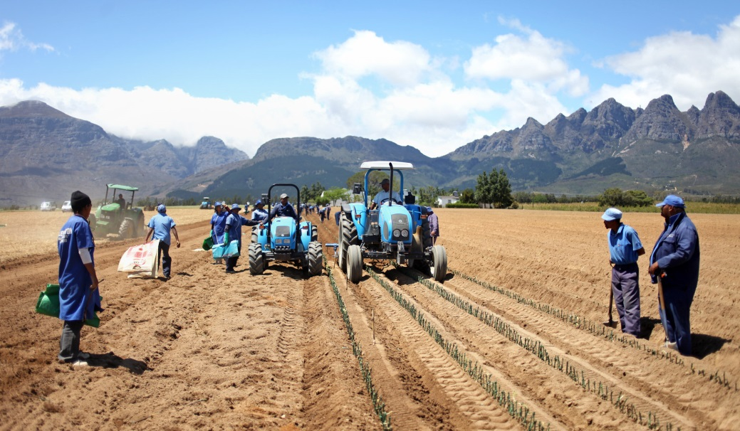

THE IMPACT OF FAIRTRADE IN SOUTH AFRICA
For every Fairtrade product sold part of the price the consumer pays goes back to the farming communities to invest in projects to empower themselves and their communities.

In 2013, farming communities on Fairtrade certified farms received over R12million in Fairtrade Development Premium, which they invested in 120 projects as follows:

- 46% in Community Investments (sport programmes, pension schemes, crèches and mentorship programmes);
- 20% in Infrastructure Improvements (upgrading housing, community centres, old age homes, computer and furniture for other projects);

- 17% in Education & Training (school fees, bursaries and skills development);
- 14% in Other (organic seed schemes and community vegetable gardens) and
- 3% in Health (alcohol rehabilitation programmes).

The premium is earned on both local and international sales of Fairtrade labelled products.

# # # END # # #

For more information or to set up interviews, please contact Lynsay Sampson, Marketing and PR Coordinator on Lynsay@FairtradeSA.org.za or 021 448 8911

