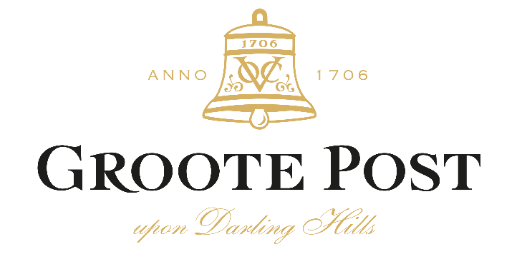

ENJOY DEBBIE MCLAUGHLIN’S SMOKED SALMON TROUT SALAD
WITH GROOTE POST’S #SEASALTER2021

Debbie McLaughlin, cordon bleu chef patron at Hilda’s Kitchen, the much-loved restaurant at Groote Post, has used her culinary creativity to devise a special seafood dish to perfectly complement Groote Post’s #Seasalter2021.

See Below Debbie’s recipe for Smoked Salmon Trout and New Potato Salad with a Lemon Mayonnaise Dressing

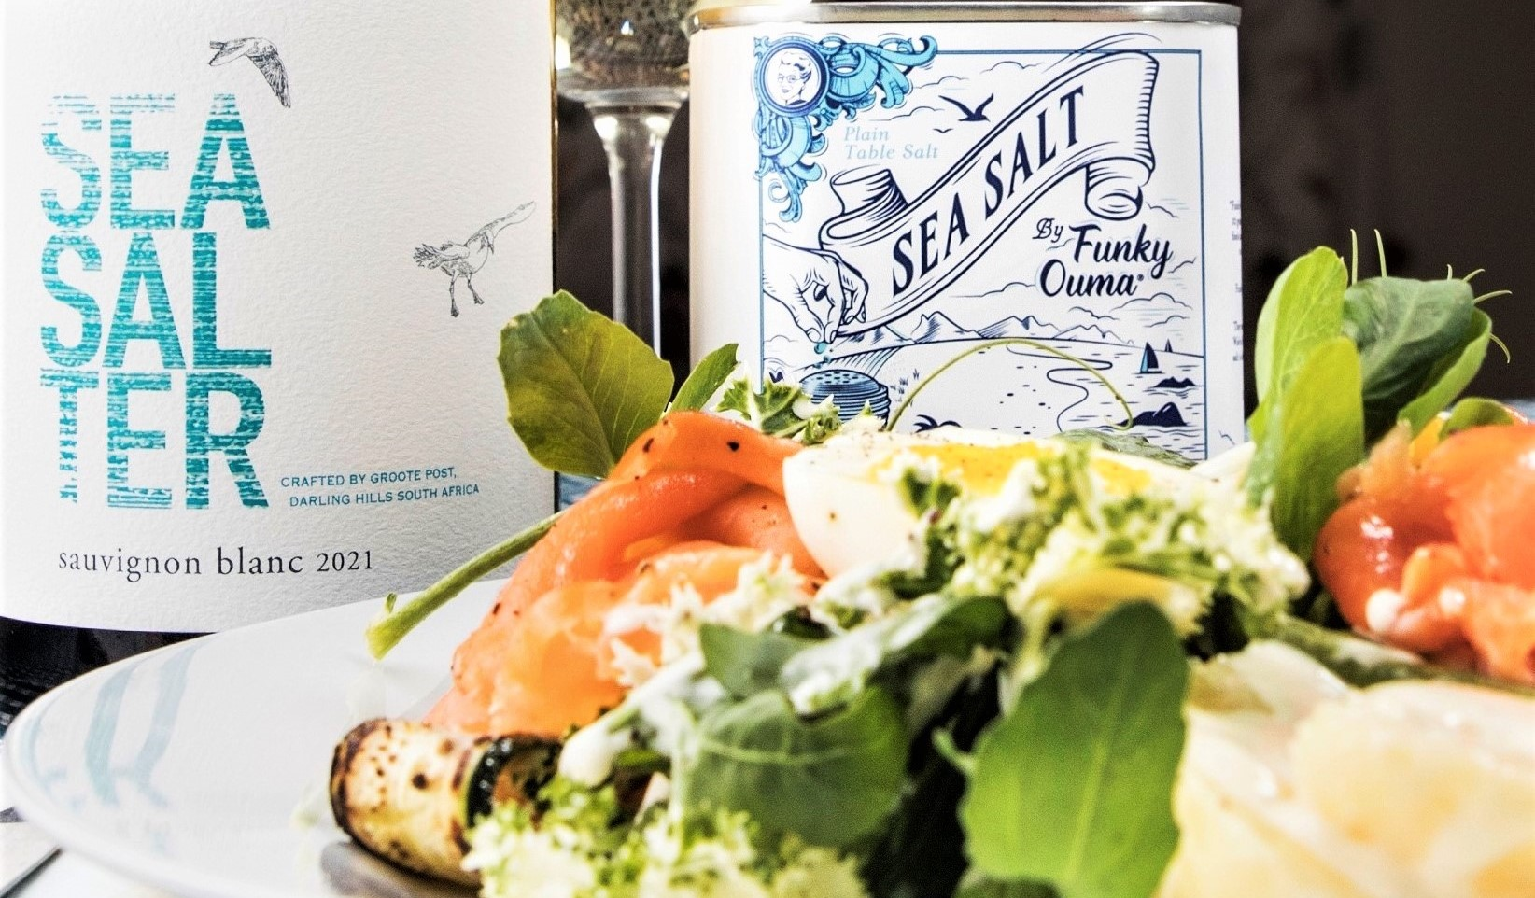

.
SMOKED SALMON TROUT AND NEW POTATO SALAD

Ingredients
500g Peeled and cooked new potatoes
250g Smoked salmon trout
180g Mixed salad leaves
12 Thin green beans, blanched
2 Medium boiled eggs, peeled
2 Sliced chargrilled courgettes
100ml Darling Olives Extra Virgin Olive Oil
50ml Freshly squeezed lemon juice
1T Red wine vinegar
*Funky Ouma Sea Salt (Seasoning)
Freshly ground black pepper (Seasoning)

Method
Combine the olive oil, lemon juice, vinegar, Funky Ouma Sea Salt and pepper. Mix well. Pour over cooked new potatoes and adjust seasoning. Divide potatoes, green beans courgettes and eggs among four plates, top with mixed salad leaves and the smoked salmon trout. Drizzle with lemon mayonnaise dressing.

*Funky Ouma Sea Salt is rich in minerals, natural and unrefined, and harvested by hand the traditional way. The slightly granular salt is extracted from a unique aquifer on the Cape West Coast, where the seawater is filtered through sand and mussel banks and thus provides additional calcium. The salt crystals, created by the sun and wind, are packed straight from the pans with their minerals intact. It is a table salt! Use every day according to your needs and taste buds.
All Natural / No Preservatives / No Msg / Non-Iodated Salt / No Colourants / Gluten Free / Vegan Friendly
https://funky-ouma.co.za/

LEMON MAYONNAISE DRESSING

Ingredients
1 Egg yolk
Zest of one lemon
50ml Freshly squeezed lemon juice
100ml Mild oil
Funky Ouma Sea Salt (Seasoning)
Freshly ground black pepper (Seasoning)

Method
Place egg yolk, zest and juice of lemon, Funky Ouma Sea Salt, pepper in a food processor. Slowly add the oil. Adjust seasoning.

ENJOY WITH A GLASS OF GROOTE POST SEASALTER 2021

Seasalter is fast becoming Groote Post’s celebrated wine, with its West Coast saltiness and minerality from the nearby Atlantic. #Seasalter2021 is wonderfully expressive on the nose exuding fragrant guava and gooseberry nuanced by blackcurrant and citrus notes with subtle aromas of kelp and passionfruit. This complex and integrated nose follows through onto the palate with captivating yellow fruit and a zesty lime acidity with hints of fynbos, sea-breeze and a touch of oak. Rich layered and long, this subtly powerful blend is intense but not weighty: an elegant well-balanced wine showing typical Darling minerality, vibrant acidity and some leesy complexity before a saline finish.

#Seasalter2021 is available from the Groote Post cellar door, online at https://groote-post-wines.myshopify.com/collections/all and at select fine wine merchants around the country.
Approximate retail price: R159

