JOURNEY’S END’S WINEMAKER, MIKE DAWSON, SHARES HIS WHITE WINE MUSSEL SOUP RECIPE
TO BE ENJOYED WITH JOURNEY’S END WEATHER STATION SAUVIGNON BLANC

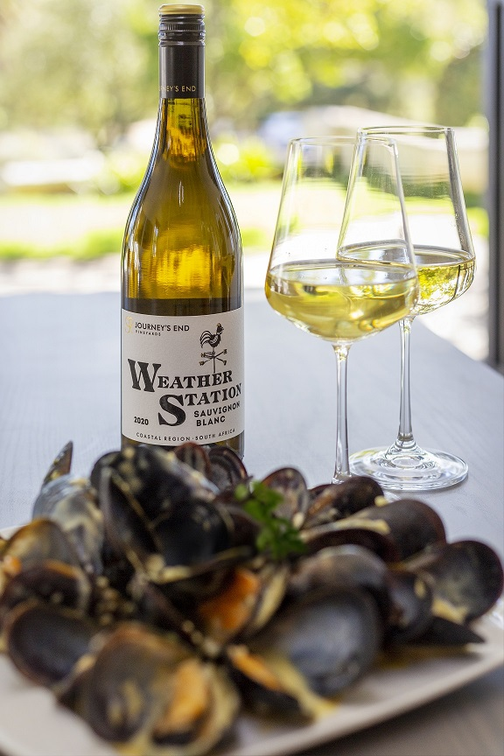
Mike’s comments on the Weather Station pairing with his White Wine Mussel Soup recipe
“It is a fresh style of wine, with beautiful natural acidity and tropical fruit flavours, which makes it a perfect pairing with seafood, of which mussels is my favourite. The freshness of the wine cuts through the creaminess of the soup. This is a match made in heaven.”

WHITE WINE MUSSEL SOUP RECIPE

Ingredients

- 3kg fresh mussels
- 2 onions (from my garden)
- 1 leek (from my garden)
- 2 celery sticks (from my garden)
- 1 cup of water
- 1 cup of chicken broth
- 1 cup of Journeys End “Weather Station Sauvignon Blanc” (be a little more generous if you are feeling adventurous)
- 1 cup of clam juice (you can also buy canned clams and drain out the juice, or if you can’t find canned clams, then substitute with another cup of chicken broth)
- A quarter cup of fresh parsley (from my garden)
- 3 mashed garlic cloves (from my garden)
- Salt and pepper of course
- 1 cup of cream

Method

- Add onions, leeks, celery, parsley, garlic, water, wine, chicken broth, clam juice, salt and pepper into a potjie pot over hot coals, and bring this to boil
- Reduce the heat, add the mussels, cover, and simmer for 5 mins or until mussels have opened
- Add the cream right at the end and you’re good to go
- This recipe serves four, but my girlfriend Tynika and I are more than capable of finishing two servings each

ENJOY WITH JOURNEY’S END “WEATHER STATION SAUVIGNON BLANC”

